**PROJECT DESCRIPTION**

**GROUP NAME**

Brogrammers 2.0.2

**TEAM MEMBERS**

* Jason Green
* Chase Grossman
* Vijayanta Jain
* Ryan Jones
* Louis Joseck
* Felix Perez

**APP NAME**

Game of Codes

**APP CATEGORY**

Game

**GENERAL OVERVIEW**

We are developing is a web-based game that is a puzzle platformer which teaches players the fundamental logic behind programming. Our design encourages problem solving and critical thinking for the player to progress. The game will have different levels each being more complicated than the previous one and utilizing the concepts from the previous lesson. Our goal is to teach fundamental programming concepts to individuals while playing a fun puzzle platformer.

Below is a conceptual sketch of our proposed game

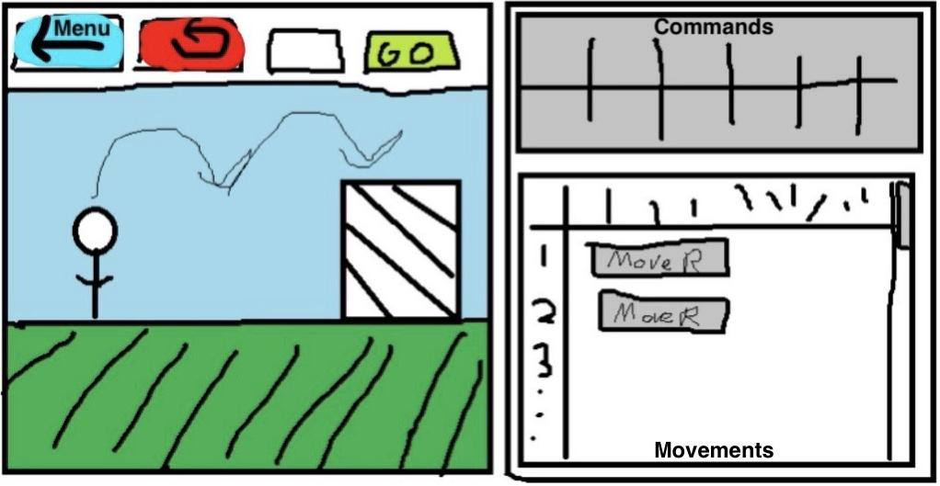

**OVERVIEW OF SIMILAR APPS**

1. Human Resource Machine (Tomorrow Corporation, 2015)

|  |  |
| --- | --- |
|  | Human Resource Machine is a video game for PC and Mobile platforms that presents problems the player must solve by creating a small program on the left hand side that controls the character in the center of the screen to perform the written solution. The game’s drag-and-drop programming blocks are reminiscent of assembly programming, but is still accessible to many who wish to enjoy a good puzzle game. This game can be used as a tool for familiarizing the player to assembly language concepts, which is similar to our design of making complex programming ideas accessible. |

1. Google Doodle (Celebrating 50 years of kids coding, 2017)

|  |  |
| --- | --- |
|  | Google often has doodle on its homepage to mark important events in history. In 2017 during the Computer Science Education Week on December 4th, Google published a programming doodle. The doodle is a puzzle that teaches kids (intended audience but fun for adults too) basic programming thinking. The storyline of the game is that a furry bunny wants to eat carrots and users use drag-and-drop boxes, such as go forward, turn, and loops, to control the bunny. Each level is more challenging and uses lessons learned from the previous to build on the complexity of lesson and the challenge. Our game would be similar to the doodle in spirit but would differ in view, levels, and storyline. |

1. Scratch (MIT Media Lab, 2002)

|  |  |
| --- | --- |
|  | Scratch is a desktop application which enables the user to use a visual programming language to create interactive stories or games. The user can load a background image and then use the visual programming language to create a game which interacts with the background. Our application is similar to Scratch because they both involve a visual programming language. Scratch is used as a tool to help children think creatively and use critical thinking similar to the thinking used in programming. Our application also teaches the user to think like a programmer. |